1. Install Jupyter notebooks into Arcpy folder:
   * + In Windows explorer navigate to C:\Python27\ArcGIS10.5\Scripts
     + type“cmd” in the folder address line (shown in yellow below)
     + Type “pip install jupyter” in the command window (please let me know if this does not work).

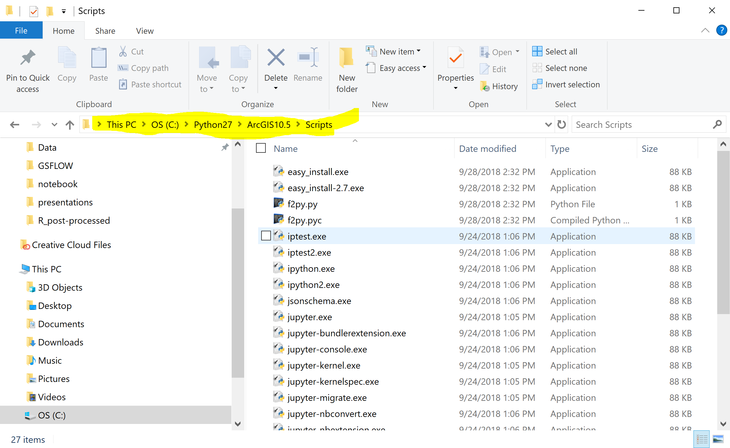

1. Install pyprms into Arcpy folder
   * + Copy pyprms folder from .\gw3099_classrepo\exercises\GSFLOW\prmspy
     + Paste pyprms folder into C:\Python27\ArcGIS10.5\Lib\site-packages.
2. Open Jupyter Notebook
   * + Navigate to .\ gw3099_classrepo\exercises\GSFLOW\notebook
     + Right click on “jupyter.bat” file and open in text editor.
     + In jupyter.bat change path “C:\Python27\ArcGIS10.5\Scripts\jupyter-notebook.exe” to be correct for your computer; save and close the file.
     + Double click jupyter.bat and the notebook should open.